Software Requirement Specification(SRS) for

Online Truck Transportation System

# Introduction

### 1.1 Purpose:

This document is meant to delineate the features of online Truck Transportation System, so as to serve as a guide to the developers on one hand and software validation document for the prospective client on the other.

It is a system design especially for large, premium and small Truck Transportation system. The truck transportation system provides complete functionality of listing and booking trucks and creating orders for certain destinations.

### 1.2 Scope:

This system allows the Customer can easily get the Truck whenever they need the items to be delivered and the truck owner can also see the orders available for desired destinations which he wants to transport with use of this system.

### 1.3 Definitions:

TRS- Truck Transportation System

SRS- Software Requirement Specification

GUI- Graphical User Interface

**1.5 Overview:**

It is a system design especially for large, premium and small truck Transportation business. The Truck Transportation system provides complete functionality of listing and booking trucks.

This proposed system can be used by any native users and it does not require any educational level,experience or technical expertise in computer field but it will be of good use if user has the good knowledge of how to operate a computer.

**EXISTING SYSTEM**

* An existing system provides manually paper work.
* The user has to go to the transport office where truck owner can get the orders placed by the customers.
* Another method which exists in this system is that the truck owner has to contact his connections and make calls to get orders and the customer also need to look for transport office from which he can get transport.

**NEED FOR NEW SYSTEM**

* The new system is totally computerized system.
* A new system provides features like time efficiency to show Truck details, user profiles and whatever the customer wants to place the order.
* This system provides online creating orders and booking system for customer.
* An inquiry is easily done by customer where he can view available trucks in the system.
* It is the most software application for managing online Truck Transport business.

**2.Overall Description**:

The Truck Transportation System application enables customer to create a order, manage booking and book trucks and also view orders and , User to view information of available trucks, booking order, easily get the truck for items to be delivered. Also the developer is designing an online truck transportation site to manage the trucks in the portal and also help customers and truck owners to book them online without visiting the center physically .The online truck transportation system will use the internet as the sole method for booking trucks for customer.

**2.1 Product Perspective**:

This product aimed toward a person who don’t want to visit the transport center as he might don’t get time for that or might not interested in visiting there and dealing with lot of formalities.

**2.2 Product Functions**:

Truck Transportation System should support this use case:

**Use Case Diagrams** :A Use case is a description of set of sequence of actions. Graphically it is rendered as an ellipse with solid line including only its name. Use case diagram is a behavioral diagram that shows a set of use cases and actors and their relationship. It is an association between the use cases and actors. An actor represents a real-world object. Primary Actor - Sender, Secondary- Actor Receiver.

**Use case diagram for Truck Owner**

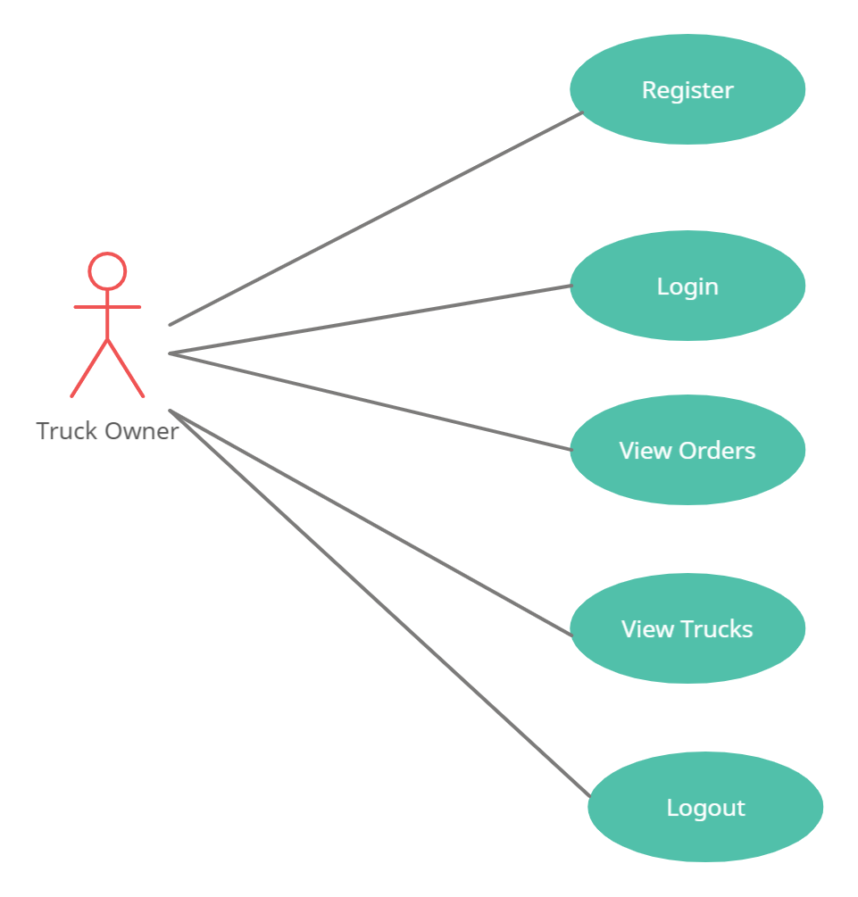

**Use Case diagram for Customer**

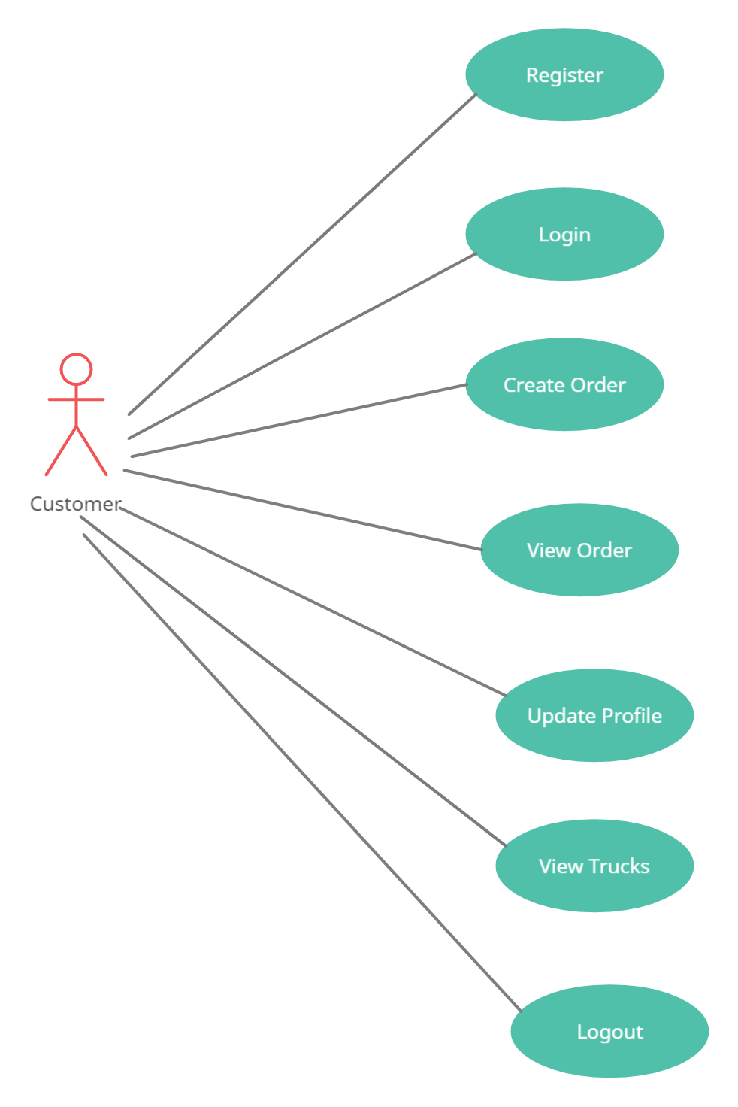

**2.3 User Characeristics**:

User should be familiar with the terms like login, register etc.

**2.4 Principle Actors**:

2 Principle Actors are Customer and Truck owner.

**2.5 General Constraints**:

A full internet connection is required for TRS.

**2.6 Assumptions and Dependencies**:

Working of TRS need Internet Connection.

**3. Specific Requirements**:

3.1 **FUNCTIONAL SPECIFICATION**

User Specification

**Customer:**

Customer can create order, manage booking of available trucks and rent them and also view trucks as well as available orders.

**Truck Owner:**

Truck owner can register himself whith his vehicle no. and view information of available orders for the locations and easily get the orders.

**MODULE SPECIFICATION**

**Customer**

**•View Available Trucks:**

It is a system design especially for large, premium and small car rental business. The customer can view Available trucks and customer can book for that truck.

**•Booking Trucks:**

The customer can view Available trucks and customer can book that truck.

**•Easily Get the Trucks on rent:**

The Customer can easily get the truck whenever they need to on the rent with use of this system.

**•Create Order:**

The customer will create the orders for the truck owners.

**•View Orders:**

The customer can view orders placed by all customers.

**Truck Owners:**

**Dashboard:**

In this section customer and truck owner can view the overview of the truckrental (Like total vehicles, total bookings, brands enquiry)

**Truck Owner Registration:**

Truck owner can register himself with his vehicle no. and the type of container which he possesses.

**View Orders for truck owner:**

The truck owner can view the orders available material weight, its quantity and material prie on this portal.

**Bookings:**

Customer can manage the bookings (confirm and cancel the booking)

**Manage testimonials:**

User can manage the testimonials (Active and Inactive the testimonials).

**Manage Contact us query:**

User can manage Contact us query.

**Registered users:**

Customer and Truck Owner.

**Manage pages:**

Admin can update the pages data information.

**Contact info:**

Admin can update the contact info.

**3.2 Non-Functional Requirements**:

Following Non-Functional Requirements will be there in the

insurance to the internet:

(i) Secure access to consumer’s confidential data.

(ii) 24X7 availability.

(iii) Better component design to get better performance at peak

time.

(iv) Flexible service based architecture will be highly desirable for

future extension. Non-Functional Requirements define system

properties and constraints.

Various other Non-Functional Requirements are:

➢ Security

➢ Reliability

➢ Maintainability

➢ Portability

➢ Extensibility

➢ Reusability

➢ Compatibility

➢ Resource Utilization

**3.3 Performance Requirements**:

In order to maintain an acceptable speed at maximum number ofuploads allowed from a particular customer as any number of userscan access to the system at any time.Also the connections to the servers will be based on the attributes of theuser like his location and server will be working 24X7 times.

**3.4 Technical Issues**:

This system will work on client-server architecture. It will require an internetserver and which will be able to run PHP application. The system should support some commonly used browser such as IE, mozzila firefox, chrome etc.

**HARDWARE REQUIREMENT**

Hardware requirements for insurance on internet

will be same for both parties which are as follows:

|  |  |
| --- | --- |
| **RAM** | 2 GB |
| **Hard disk** | 320 GB |
| **Processor** | Dual Core |

**Software Requirements**

**Client side:**

|  |  |
| --- | --- |
| **Web Browser** | Google Chrome or any  compatible browser |
| **Operating System** | Windows or any equivalent OS |

**Server side:**

|  |  |
| --- | --- |
| **Web Server** | TOMCAT |
| **Server side Language** | ANGULAR |
| **Database Server** | MYSQL |
| **Web Browser** | Google Chrome or any  compatible browser |
| **Operating System** | Windows or any equivalent OS |

**Communication Interfaces**:

The two parties should be connected by LAN or WAN for the communication purpose.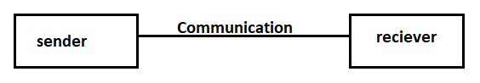

**5.System Design Specification:**

**System Flow Chart**

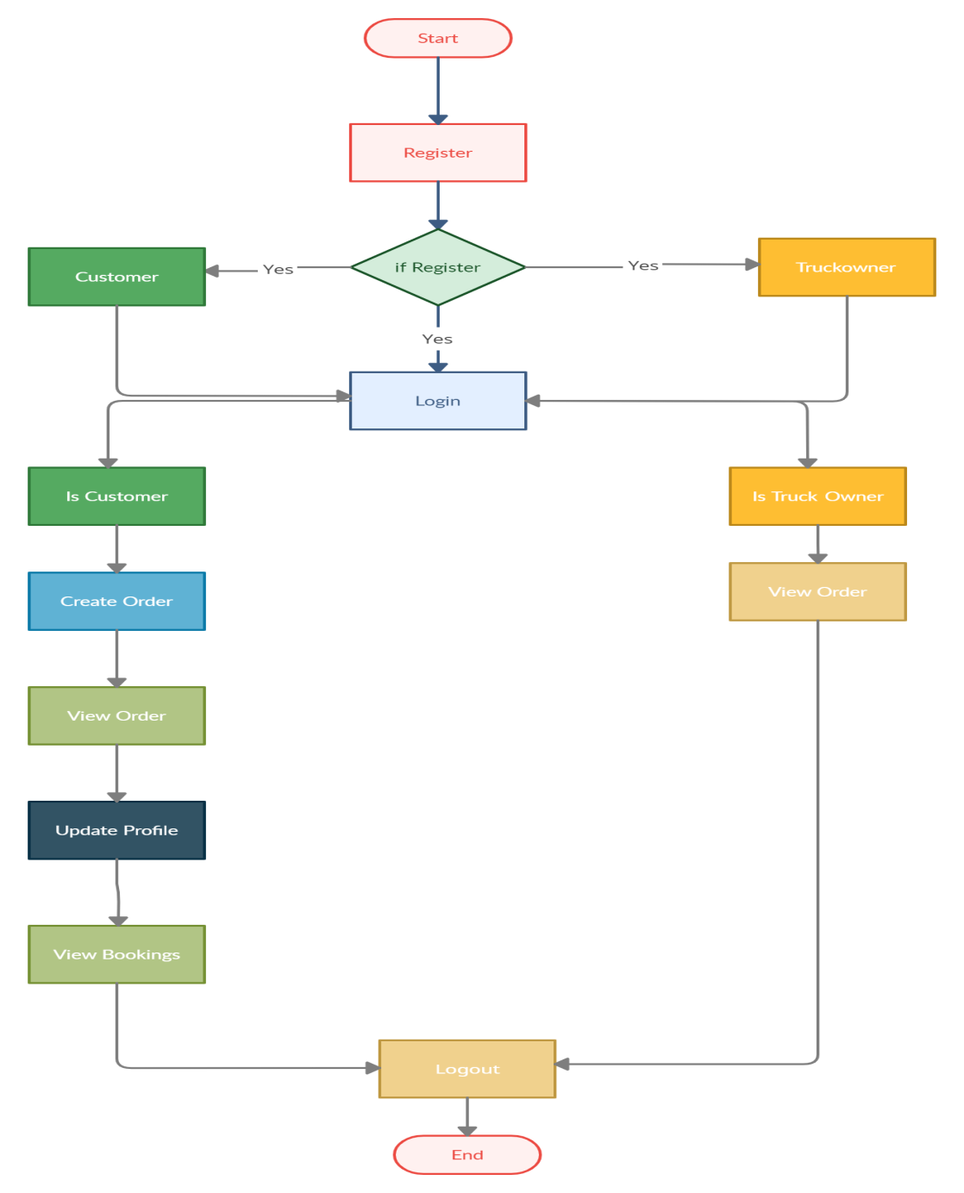

**ER DIAGRAM**

The Entity-Relationship (ER) model was originally proposed by Peter in 1976 [Chen76] as a way to unify the network and relational database views. Simply stated the ER model is a conceptual data model that views the real world as entities and relationships. A basic component of the model is the Entity-Relationship diagram which is used to visually represent data objects. Since Chen wrote his paper the model has been extended and today it is commonly used for database design for the database designer, the utility of the ER model is:

* It maps well to the relational model. The constructs used in the ER model can easily be transformed into relational tables.
* It is simple and easy to understand with a minimum of training. Therefore, the model can be used by the database designer to communicate the design to the end user.
* In addition, the model can be used as a design plan by the database developer to implement a data model in specific database management software.

.

**Entity Relation Diagram**

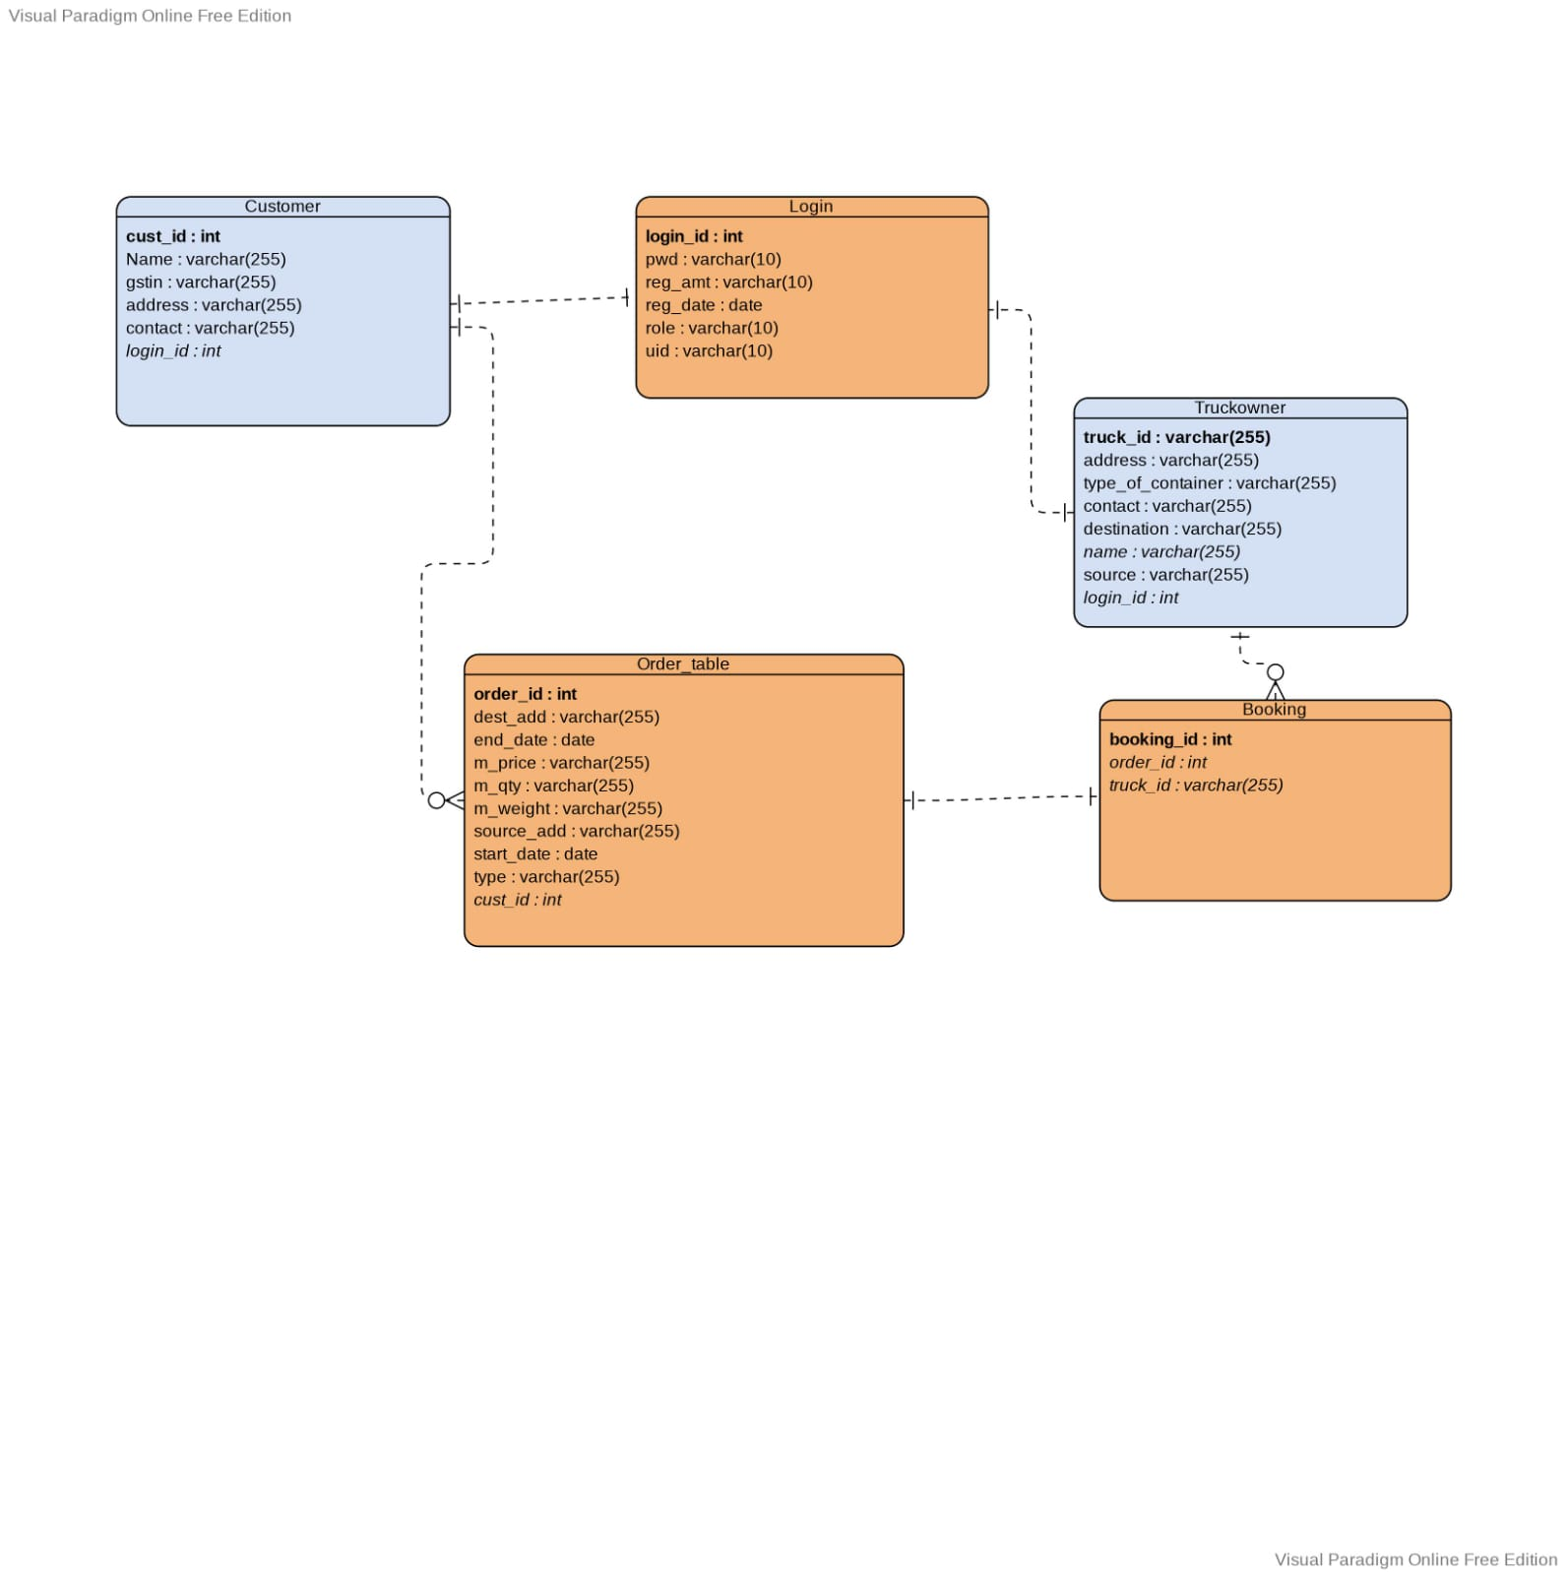

**Activity Diagram for Customer**

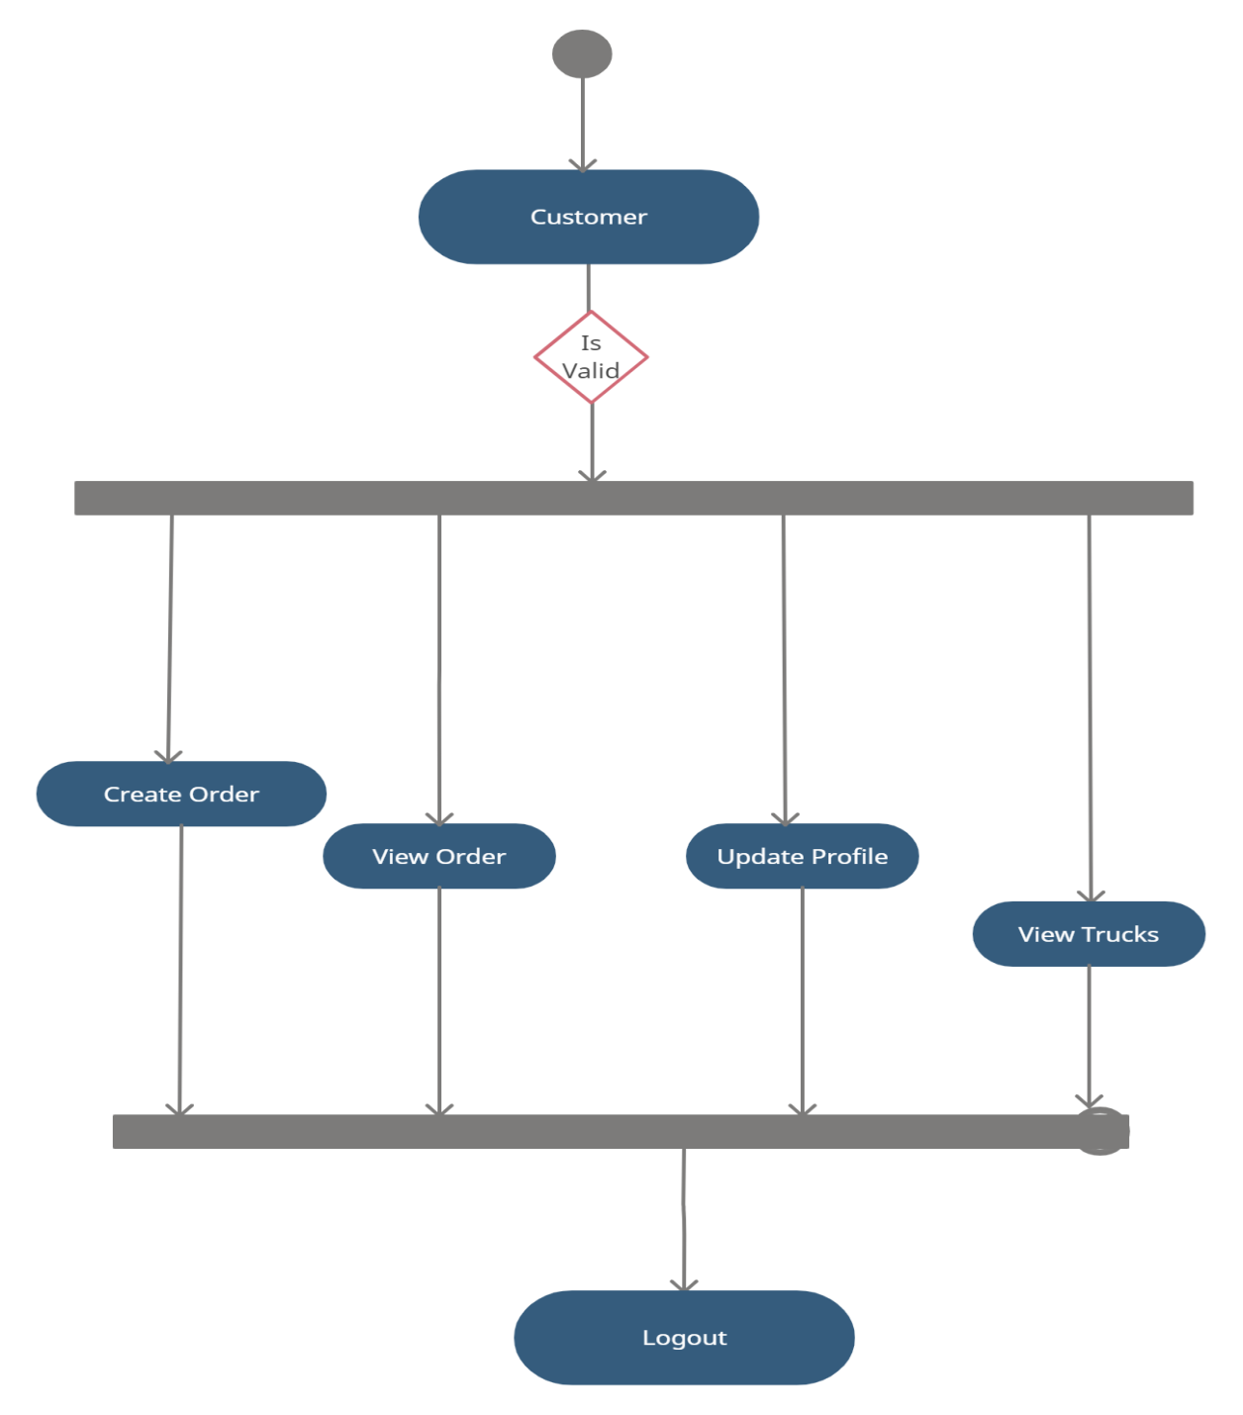

**Activity Diagram for Truck Owner**

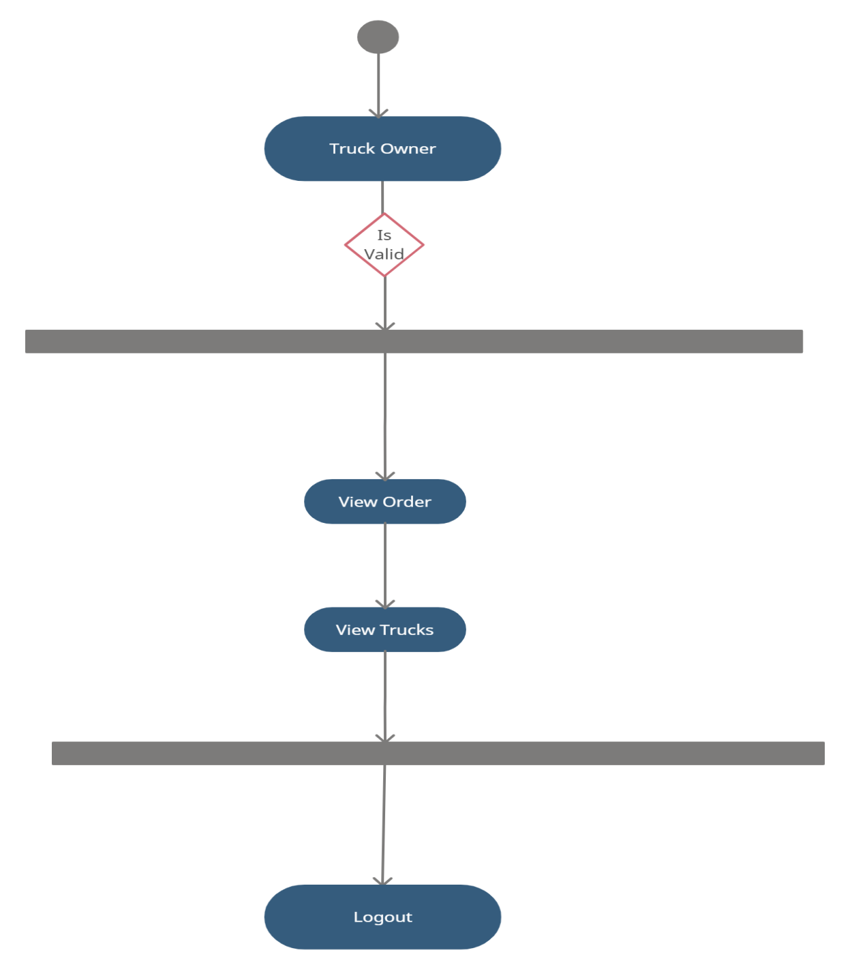

**DATABASE DESIGN**

The data in the system has to be stored and retrieved from database. Designing the database is part of system design. Data elements and data structures to be stored have been identified at analysis stage. They are structured and put together to design the data storage and retrieval system.

A database is a collection of interrelated data stored with minimum redundancy to serve many users quickly and efficiently. The general objective is to make database access easy, quick, inexpensive and flexible for the user. Relationships are established between the data items and unnecessary data items are removed. Normalization is done to get an internal consistency of data and to have minimum redundancy and maximum stability. This ensures minimizing data storage required, minimizing chances of data inconsistencies and optimizing for updates. The MS Access database has been chosen for developing the relevant databases.

**Customer Registration:**

|  |  |
| --- | --- |
| **Table Name** | Customer |
|  |  |
| **Description** | This table is provide the information about Customer. |
|  |  |
| **Primary Key** | Id |
|  |  |
| **Foreign Key** | login_id |
|  |  |

|  |  |  |  |  |
| --- | --- | --- | --- | --- |
| **Sr.** | **Field Name** | **Data type(Size)** | **Constraints** | **Description** |
| **No** |  |  |  |  |
|  |  |  |  |  |
| 1. | Cust_id | int | Primary key | It is store customer id |
|  |  |  |  |  |
| 2. | address | Varchar(255) | Null | It is store address of User |
|  |  |  |  |  |
| 3. | contact | Varchar(255) | null | It is store contact of customer |
|  | conta |  |  |  |
| 4. | Gstin | Varchar(255) | null | It is store gstno |
|  |  |  |  |  |
| 5. | name | Varchar(255) | null | It is store full name of customer |
|  |  |  | null |  |
| 6. | Login_id | int | Foreign key | It is store login id |
|  |  |  |  |  |

**Booking Table:**

|  |  |
| --- | --- |
| **Table Name** | Booking |
|  |  |
| **Description** | This table is provide the information about booking. |
|  |  |
| **Primary Key** | Booking_Id |
|  |  |
| **Foreign Key** | Order_id, truck_id |
|  |  |

|  |  |  |  |  |
| --- | --- | --- | --- | --- |
| **Sr.** | **Field Name** | **Data type(Size)** | **Constraints** | **Description** |
| **No** |  |  |  |  |
|  |  |  |  |  |
| 1 | booking_id (Primary) | int(11) | Primary Key | It is used to store booking id |
|  |  |  |  |  |
| 2 | order_id | Int | Foreign key | It is used to store order id of customer |
|  |  |  |  |  |
| 3 | truck_id | varchar(10) | Foreign key | It is used to store truck id of truck owner |
|  |  |  |  |  |

**Login Table**:

|  |  |
| --- | --- |
| **Table Name** | login |
|  |  |
| **Description** | This table is provide the information about customer and truck owner registration |
|  |  |
| **Primary Key** | Id |
|  |  |

|  |  |  |  |  |
| --- | --- | --- | --- | --- |
| **Sr.** | **Field Name** | **Data type(Size)** | **Constraints** | **Description** |
| **No** |  |  |  |  |
|  |  |  |  |  |
| 1 | id (Primary) | int | Primary Key | It is used to store login id |
|  |  |  |  |  |
| 2 | pwd | varchar(45) | Null | It is used to store User password |
|  |  |  |  |  |
| 3 | Reg_amt | varchar(45) | Null | It is used to store registration amount of User |
|  |  |  |  |  |
| 4 | Reg_date | date | Null | It is used to store registration date |
|  |  |  |  |  |
| 5 | role | varchar(10) | Null | It is used to store role |
|  |  |  |  |  |
| 6 | uid | varchar (10) | Null | It is store user id |
|  |  |  |  |  |

**Order Table:**

|  |  |
| --- | --- |
| **Table Name** | Order |
|  |  |
| **Description** | This table is provide the information about order. |
|  |  |
| **Primary Key** | order_Id |
|  |  |
| **Foreign Key** | truck_id |
|  |  |

|  |  |  |  |  |
| --- | --- | --- | --- | --- |
| **Sr.** | **Field Name** | **Data type(Size)** | **Constraints** | **Description** |
| **No** |  |  |  |  |
|  |  |  |  |  |
| 1 | Order_id (Primary) | int | Primary Key | It is used to store order id |
|  |  |  |  |  |
| 2 | Dest_add | varchar(45) | Null | It is used to store destination address of User |
|  |  |  |  |  |
| 3 | End_date | varchar(45) | Null | It is used to store end date |
|  |  |  |  |  |
| 4 | M_price | varchar(40) | Null | It is used to store material price |
|  |  |  |  |  |
| 5 | M_qty | varchar(40) | Null | It is used to store material quantity |
|  |  |  |  |  |

|  |  |  |  |  |
| --- | --- | --- | --- | --- |
| 6 | Source_add | Varchar(40) | Null | It is used to store source address |
| 7 | Start_date | date | Null | It is used to store start date |
| 8 | status | Varchar(40) | Null | It is used to store status |
| 9 | Cust_id | int | Foreign key | It is used to store customer id |

**Truck Owner:**

|  |  |
| --- | --- |
| **Table Name** | truckowner |
|  |  |
| **Description** | This table is provide the information about truckowner |
|  |  |
| **Primary Key** | Id |
|  |  |
| **Foreign Key** | login_id |
|  |  |

|  |  |  |  |  |
| --- | --- | --- | --- | --- |
| **S.No** | **Field Name** | **Data type(Size)** | **Constraints** | **Description** |
| 1. | Truck_no | Varchar(255) | Primary key | It is used to store truck no |
| 2. | address | Varchar(255) | Null | It is used to store address. |
| 3. | Availability_status | Varchar(255) | Null | It is used to store availability status |
| 4. | contact | Varchar(255) | Null | It is used to store contact no. |
| 5. | destination | Varchar(255) | Null | It is used to store destination. |
| 6. | Name | Varchar(255) | Null | It is used to store name. |
| 7. | Source | Varchar(255) | Null | It is used to store source. |
| 8. | Login_id | int | Foreign key | It is used to store login id. |

**Future Scope:**

In future this system can also be added with additional feature like Online Payment Gateway, Online Transportation Booking and online tracking of vehicles.

**Conclusion:**

The development of the proposed system provides a smoother, faster, less ambiguous and novice friendly platform to handle the operations involved in the booking system for the users on both the end along with the security and the status of the goods being transported. By the introduction of this kind of system its accessibility will become a boon to both the users to interact and settle deals with a faster medium and by eliminating the usage of traditional phone directory and the dependency on contacts to respond in time during urgencies. Thus, by using this technology the platform can connect the brokers as well as the manufacturers all over the world.